Competitive Shooters of Lake Norman USPSA November 13th, 2025
COURSE DESIGNER: Ike Starnes
START POSITION: See written stage briefings.

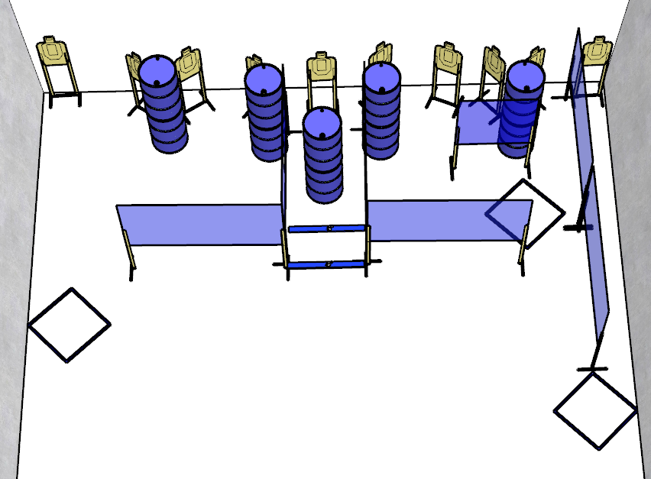

Written Stage Briefing:

Stage 2 - Attack Me With Everything You Have - is a 20-round, 100 point, Comstock Course. There are 10 cardboard targets and some noshoots. The best 2 hits per cardboard target will be scored.
Handgun start position Anywhere. The handgun is unloaded and holstered.
PCC start position Anywhere. PCC is unloaded with stock touching belt.
On the audible start signal, engage targets from within the shooting area.

